Programming Exercise 11
Pedro Clavero De Dios
April 12, 2026
COP 2373
Screenshot:
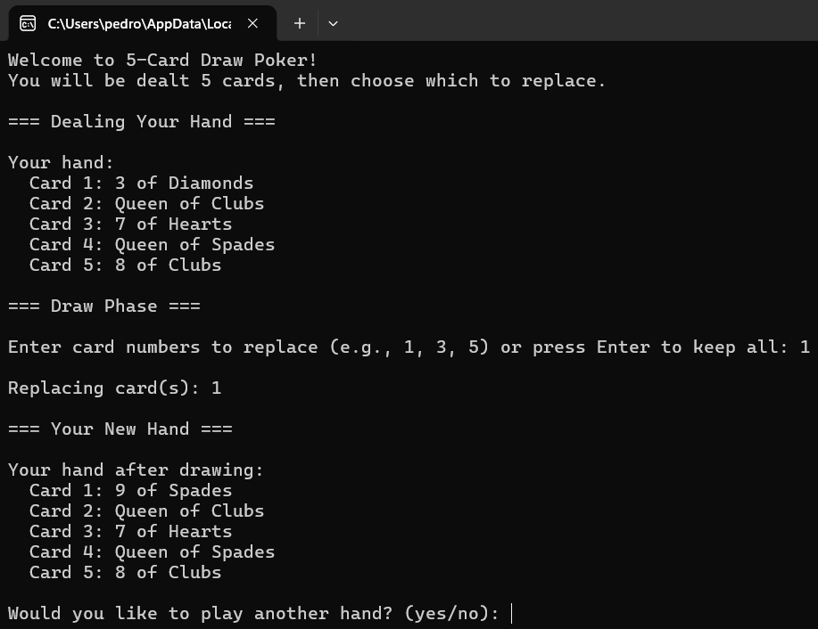
GitHub Repo Link: https://github.com/Pclav34/PC_COP2373

